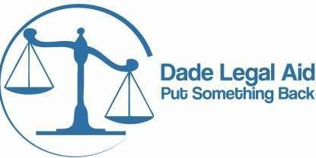**PRO BONO REPORTING FORM**

**Please Complete and Return this form to PSB@dadelegalaid.org**

**for Each Pro Bono Case That You & Others In The Firm Are Handling So That We May Track Your Pro Bono Hours – Thank You!**

**NAME OF PRO BONO ATTORNEY: _________________________________________________**

**PRO BONO ATTORNEY BAR NUMBER: ____________________________________________**

**CLIENT NAME: ________________________________________________________________**

**TYPE OF CASE: ________________________________________________________________**

**CLIENT ADDRESS: ______________________________________________________________**

**DATE CASE WAS OPENED: _______________________________________________________**

**CASE STILL PENDING: ___ Yes ___ No TOTAL HOURS TO DATE ON CASE: ______________**

**DATE CASE WAS CLOSED: _______________ TOTAL HOURS WORKED ON CASE: _________**

**CLOSING CODE (HOW WAS THE CASE CLOSED?) – Please check off below the closing code that applies to your case.**

**Limited Action: ______**

**Negotiated Settlement Without Litigation: ______**

**Negotiated Settlement With Litigation: ______**

**Administrative Agency Decision: ______**

**Court Decision: ______**

**Extensive Service: ______**

**Other: ______**

**Please returned completed form to** [**PSB@dadelegalaid.org**](mailto:PSB@dadelegalaid.org)

**or Fax: 305-372-7693 or Mail to: Attn. Vicky Dopico, Dade Legal Aid**

**123 N.W. First Avenue, Miami, Florida 33128**